**Phototroph-heterotroph interaction across *Prochlorococcus* and *Alteromonas* diversity**

Dikla Aharonovich, Osnat Weissberg and Daniel Sher

Department of Marine Biology, Leon H. Charney School of Marine Sciences, University of Haifa, Israel

**How does the diversity within a closely related group of organisms affect the outcome of their co-culture?**

1. During the initial contact (strains that had been separated and grown axenically in the lab for thousands of generations)
2. After the strains have “spent time together”, potentially adapting/acclimating to living together under different environmental conditions.
3. Pro cannot live alone – they need interactions to survive

During the initial contact, five Prochlorococcus (PRO) strains that had been separated and grown axenically in the lab for thousands of generations, transferred to grow in co-culture with a member from the Alteromonas sp. (ALT). Five strains of PRO, (representing clades HLI, HLII, LLI and LLIV) and five strains of ALT (A. macleodii and A. mediterranea) were grown in binary co-cultures, forming a 5x5 matrix of interactions encompassing the natural genetic diversity of these organisms.

**Flowchart of the experimental procedure**

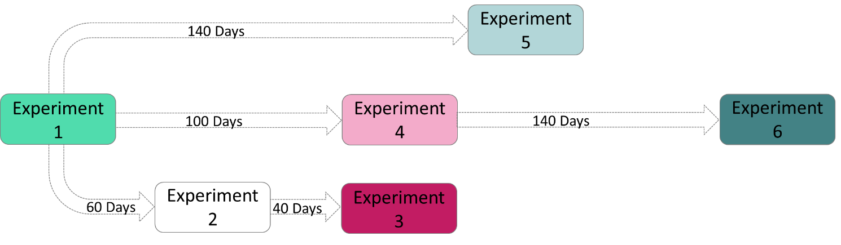

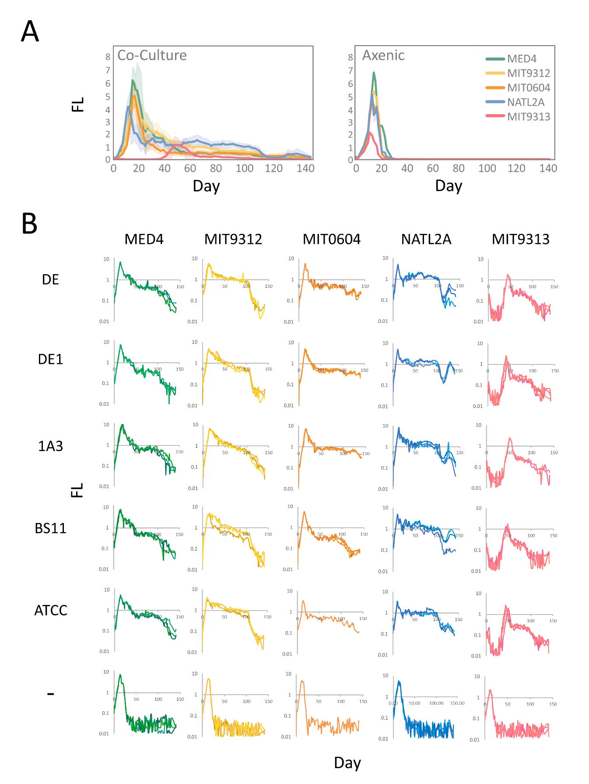**Figure 1**. The initial contact between *Prochlorococcus* and *Alteromonas* strains. A. Mean fluorescence curves over 140 days of *Prochlorococcus* strains, grown in co-culture and alone. B. Three replicates of culture fluorescence of each specific binary co-culture and axenic cultures.

It can be observed highly consistent between replicates (each replicate represents by a separate line) and differ between strains. All axenic cultures shown a similar growth pattern, with immediate decrease after the maximum growth. in addition, in co-culture there is a large difference between MIT9313 strain to all others PRO. MIT9313 is inhibited after the initial contact for 20-30 days before it started to grow

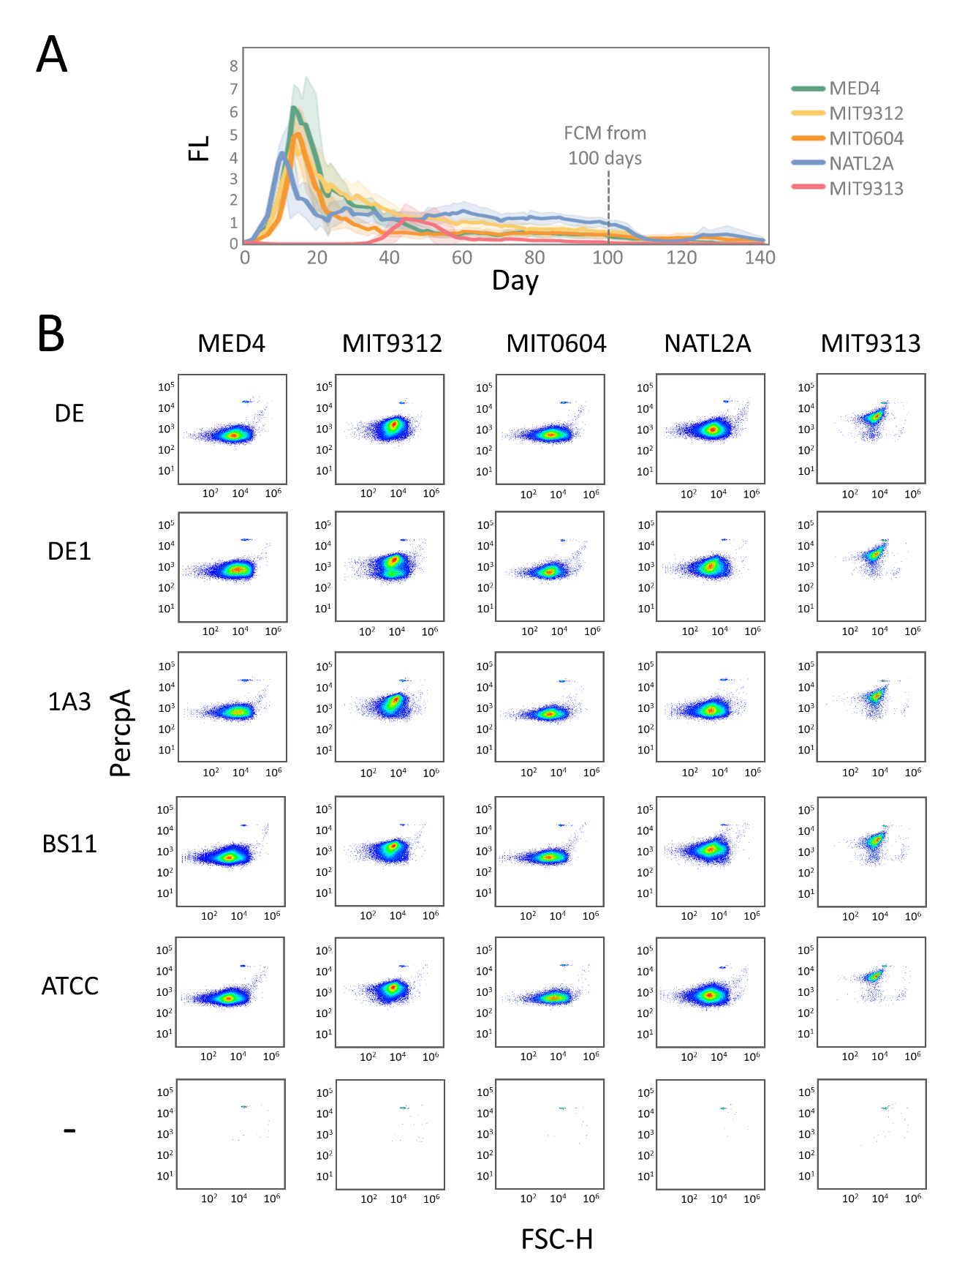

**Figure 1S**. Cell numbers in axenic and co-cultures after 100 days from the initial contact. A. Mean fluorescence curves over 140 days of *Prochlorococcus* strains, grown in co-culture. B. *Prochlorococcus* cells detected by flow cytometry (FCM). The x-axis is Forward Scatter (FSC, a proxy for cell size), the y-axis is the chlorophyll autofluorescence of the cells (Per-CP).

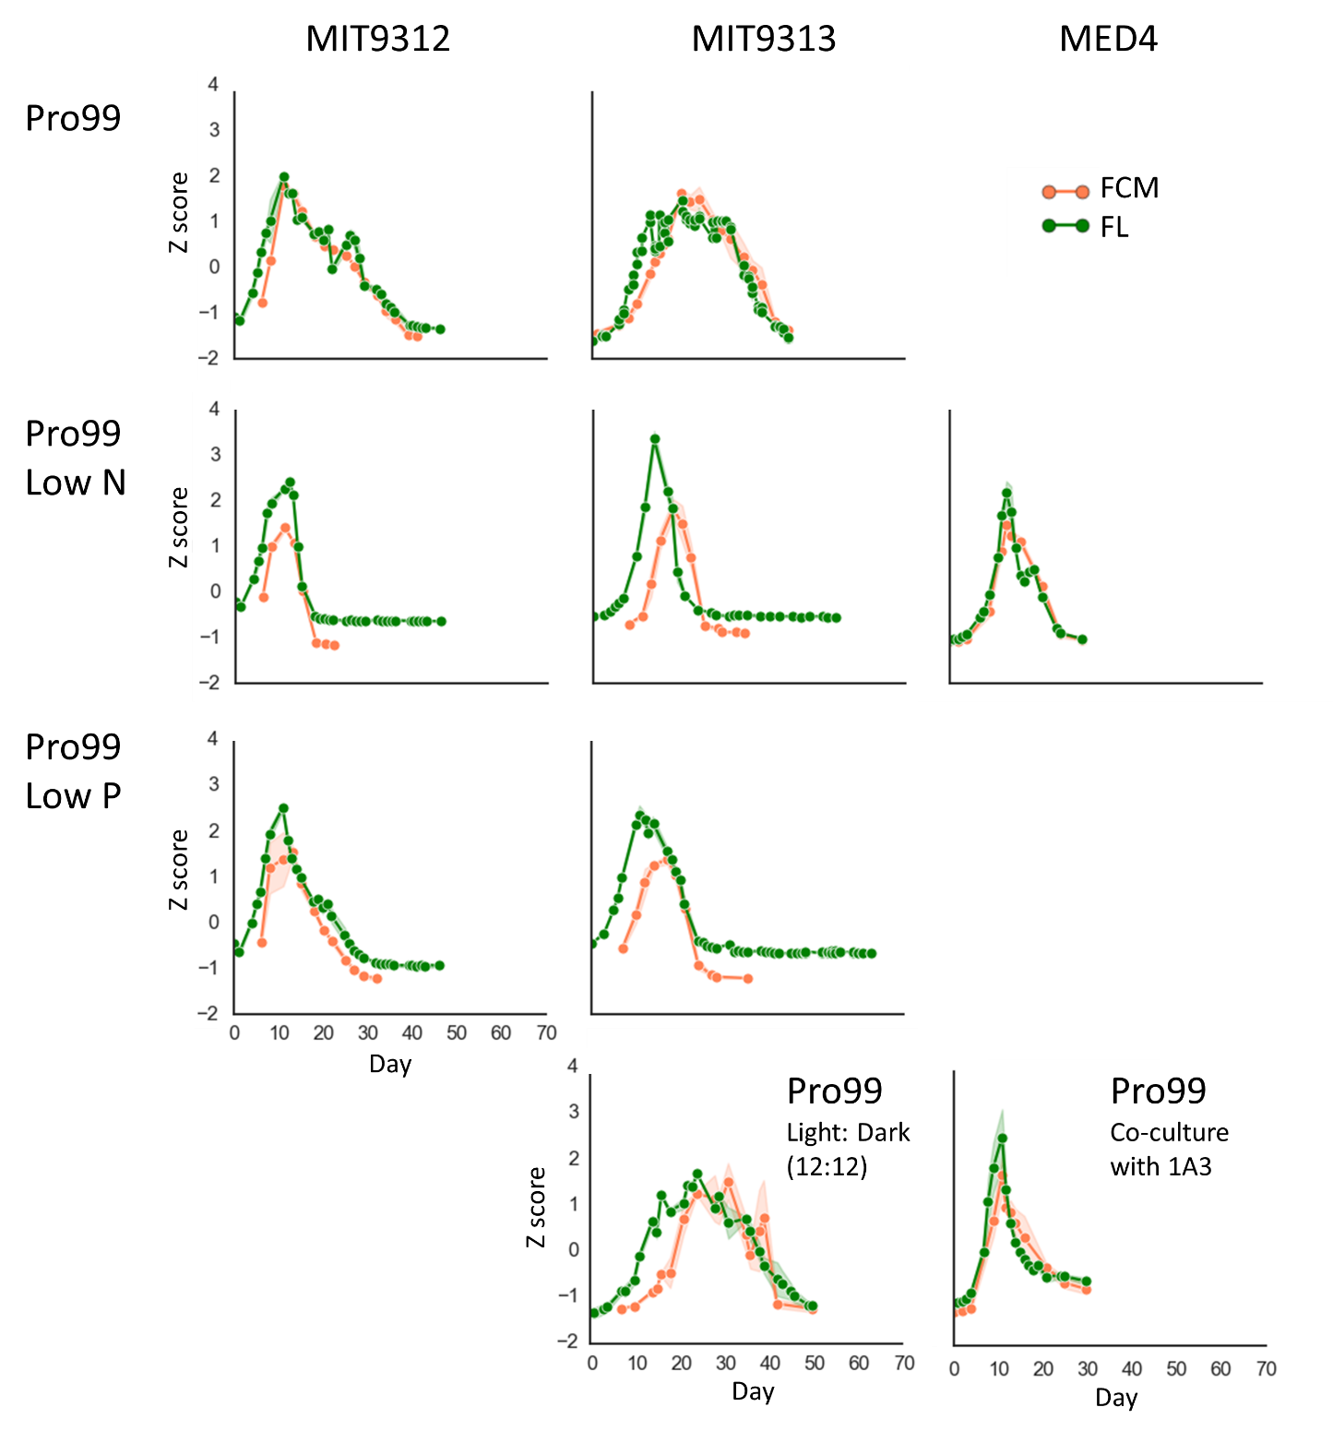

**Figure 2S**. Bulk culture fluorescence versus cell numbers counted by flow cytometry. We tested if fluorescence (FL) can represent well the culture growth curve and the cell numbers that counted by flow cytometry (FCM). Same cultures were grown under several growing conditions; Pro99 Medium, Pro99 with Low N or Low P (the N:P ratios were 2:1 and 124:1, the latter expected to result in N and P starvation leading to cessation of growth), light-dark and co-culture with Alteromonas HOT1A3 (1A3). Cultures growth and decline were measured using FL and FCM. We normalized the FL values and the cells numbers from FCM by Z score. Replicates average number is shown.

We follow bulk culture FL, which can be measured non-invasively. While FL does not fully capture the actual dynamics of cells, due to chlorosis, It can be seen that in most cases there is a high correlation and a similar growth trend between the FL and FCM values at each time point. MED4 is shown high correlation in all growing conditions, whereas, MIT9312 and MIT9313 shown high correlation mainly when grown in Pro99 medium without any limitation. In other mediums they shown similar growth trend. The noticeable difference is in the exponential growth phase where FL appears to increase faster than cell numbers (FCM).

(*maybe add correlation of growth and decline rates). However, some fine-scale dynamics observed in the FL curves (“bumps”) are not necessarily seen in cell numbers, and may represent physiological changes. **IF WE CAN SAY THAT STRAIN A DECLINES FASTER THAN STRAIN B THIS IS STRONG** We can then use this logic in the discussion: first identify major changes in decline rates (who dies faster) and then ask about the “bumps” – what strains show more physiological variation, potentially trying to “fight death’

Questions:

1. how to do correlation?

2. Choose which results to present (lowN only?)

3. y axis (normalize zscore or 2 axis)?

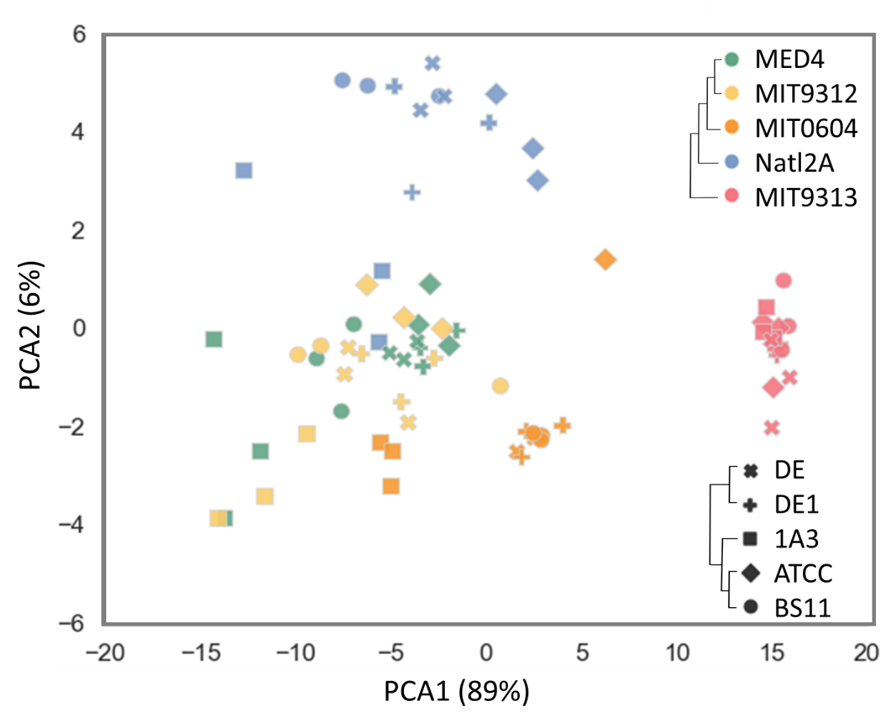

**Figure 2.** Principal component analysis (PCA) based on fluorescence data from all co-cultures growth curves during 140 days of experiment 1. The data XXX before plotting. PCA were performed with XXX software. All 3 replicates are shown in the figure and each point represents one tube from the experiment. Colors indicate the PRO and Symbols represent the ALT.

Clear differences between PRO strains. Closely related Prochlorococcus strains (MED4, MIT9312 and MIT0604) are grouped together. No clear differences between Alteromonas.

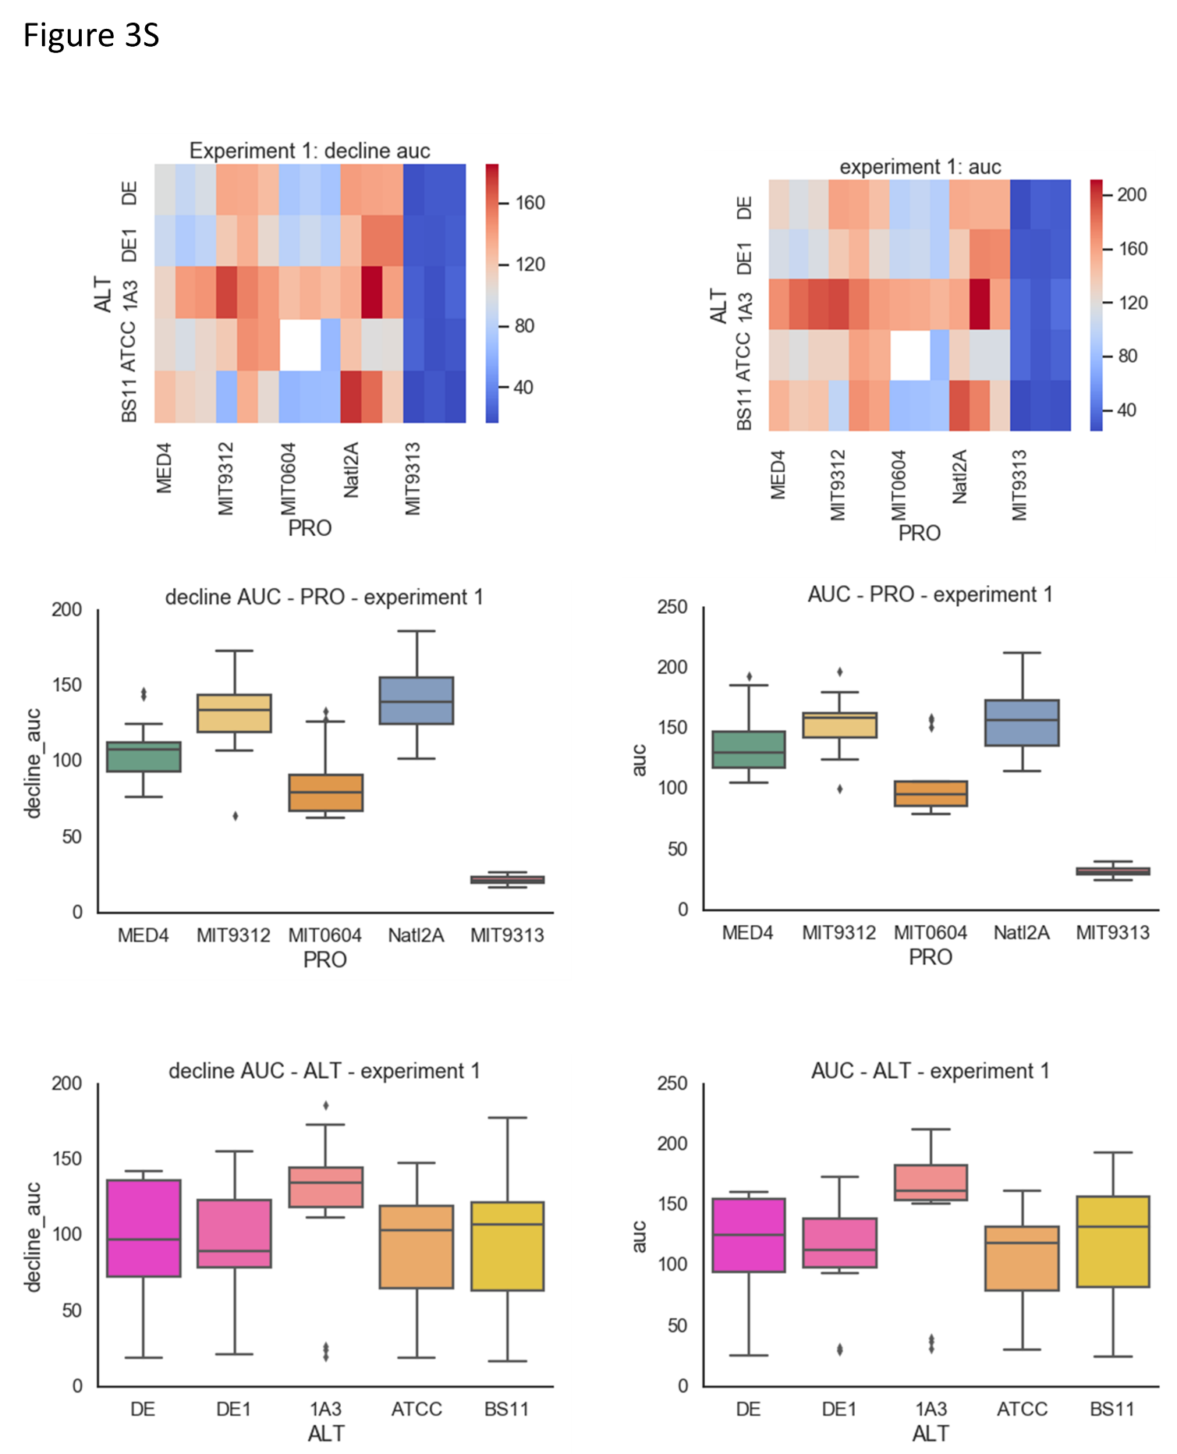

**Figure 3S.** AUC and decline AUC for experiment 1, 3 replicates heatmap . raw data, not normalized

** Need to organize the figure + legend

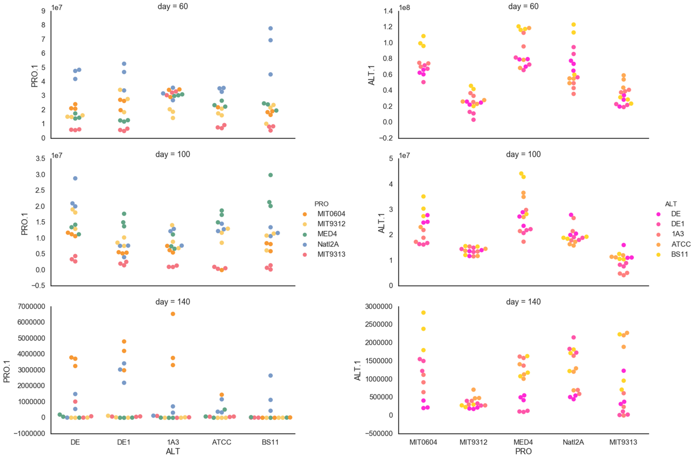

**Figure 3. FCM from experiment 1-60,100 and 140 days**

** Need to organize the figure + legend

New figure slide 2

**What happens during subsequent transfers?**

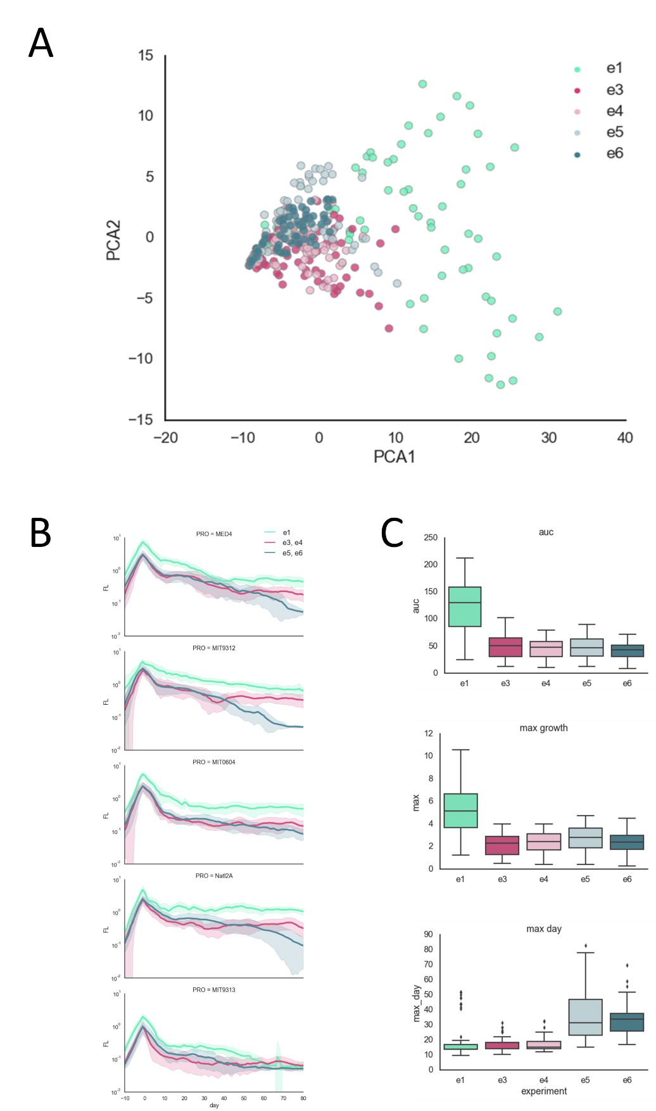

**Figure 4. experiment 1 compare to 3&4 and 5&6**

** Need to organize the figure + legend

**There are differences between transfers after 100 (3,4) and 140 (5,6) days (the 120 days “change”)**

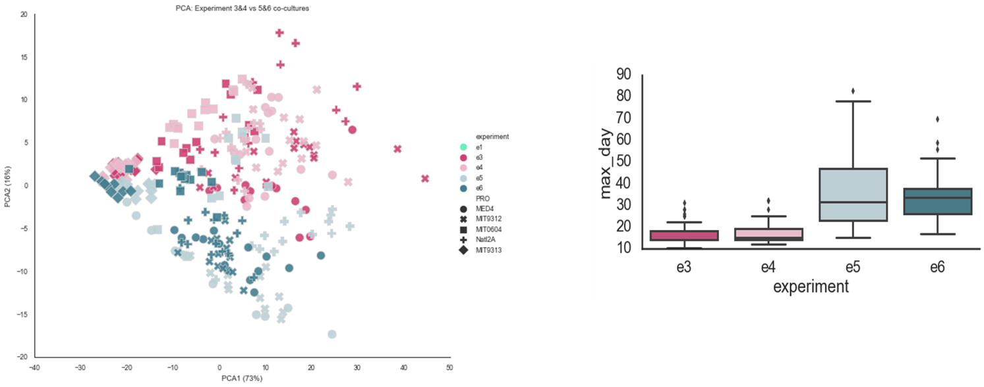

**Figure 4S. experiment 1 compare to 3&4 and 5&6**

It illustrates clearly that transfer after 140 days is different

From here

More figures and text that need to organize:

* 1. There are still differences between Pro strains and not between Alt – 9313 and 0604 most similar.

**PCA – experiment3,4 – experiment 1**

**AUC?**

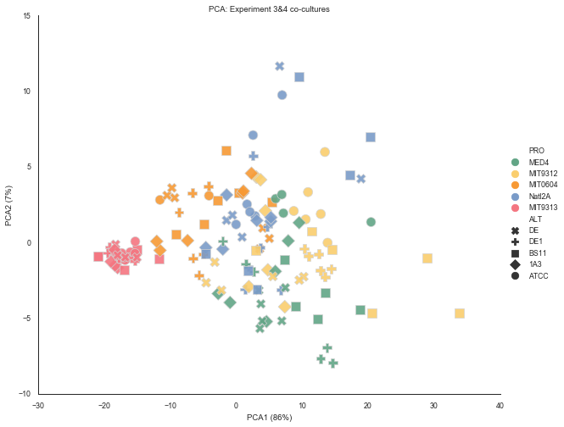

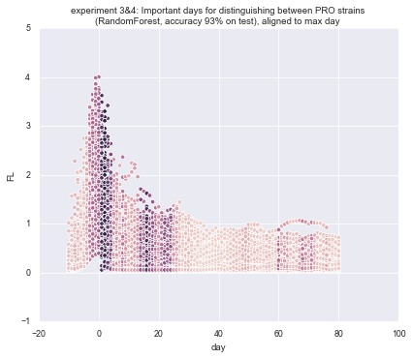

* 1. There are also differences in the number of cells (FCM data – should it go here?)

1. What are the aspects of the growth/decline that differentiate between the Pro strains?
   1. There are differences between transfers after 100 (3,4) and 140 (5,6) days (the 120 days “change”)

**PCA, feature bars**

1. Only Pro that grow with Alt survive. This includes 9313 that was initially inhibited by all Alts. They survive for at least 140 days. ** what happens after 140 days? Look at results of transfers after 185 and 220 days.
2. In experiments 3 and 4, when Pro was transferred after 100 days, there was no inhibition of 9313 in subsequent transfers (consistent with previous studies – inhibition is dose-dependent). Experiments 5 and 6 are less clear, because other strains also grew late

**All 9313 – show line side by side 1A3 – e1, 3, 4, 5, 6 *Maybe show panels for other Pro strains one above the other\*\***

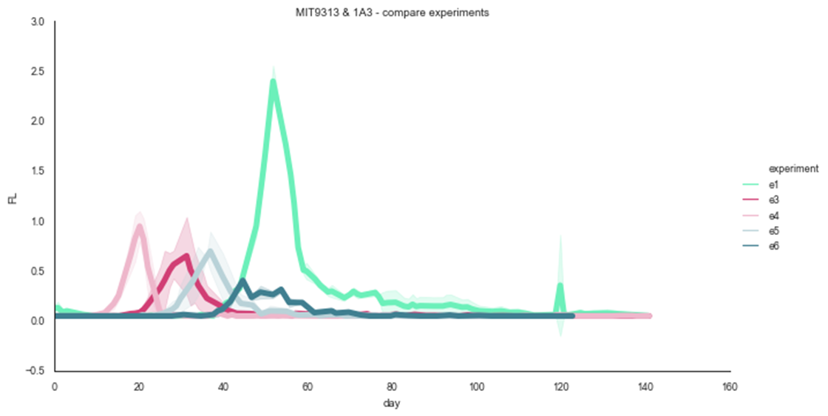

1. 9313, 0604 decline faster. Others have “bumps” (knees). These bumps are seen (to some extent) also in axenic cultures

**??**

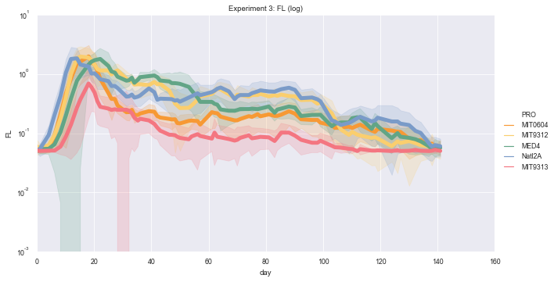

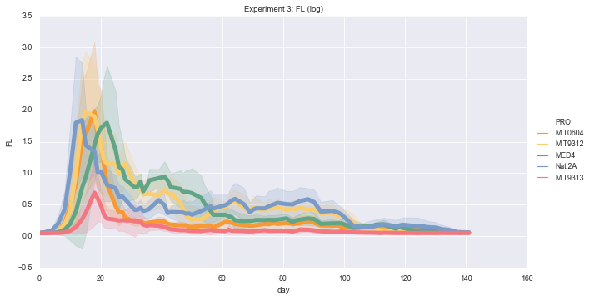

1. The bumps are related to changes in cell number (or is it fluorescence/cell? Look at the 9312 experiment and the correlations Osnat did between cell numbers and FL across experiments).
2. What are the mechanisms? We have several hypotheses
   1. Nutrient recycling (read Joseph paper, get NO3 measurements)
   2. Genetic adaptation (get re-sequencing results)
   3. Fit a model?
   4. The main differences are during the late stages (long term starvation) in the dynamics of decrease and in the final (not really steady-state) FL

**Important days e1: aligned to max, not aligned**

**e1 AUC/mean decline bar chart**

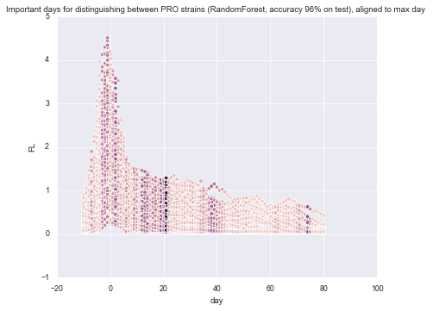

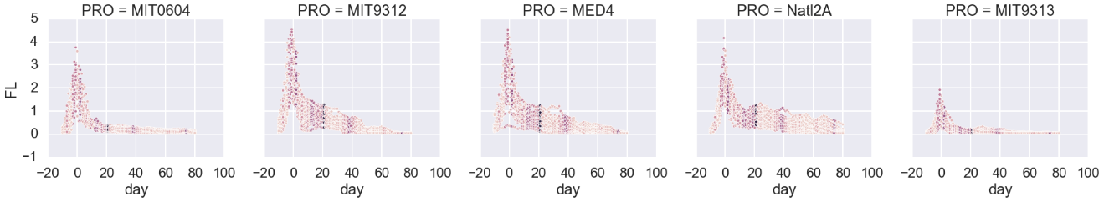

PCA of cell numbers, counted by flow cytometer, of PRO and ALT after 100 days in co-culture – Osnat

**Summary of our meeting 05/02/2020**

1. Figure 2 PCA
2. Add PCA of exp 3,4,5,6 (each one alone) and check if there is also a separation by PRO strains phylogeny (like in exp 1).

* Slide 1 – to put in **sup figure**. The same pattern is observed (9313 separated, MED4 and 9312 relatively together).

1. Change the tree of PRO (Dikla)

1. Figure 3 )FCM(
2. Add a figure of FCM count / FL (X/Y) – only dates that both have. Done slide 3, slide 5
3. Decline rate – is there any correlation between FL and FCM ? not done
4. Correlation between FL and FCM at days 60, 100 and 120 – slide 7

Cell/ml

Cell/ml

1. Add FCM figure with all ALT or PRO in days 60, 100 and 120. Slide 9 – add to figure 3

Like this:

PRO ALT

60 100 140

60 100 140

1. Change this figure for exp 1 to PRO and ALT according color (2 panel for each day 60, 100, 120) – add statistic slide 8

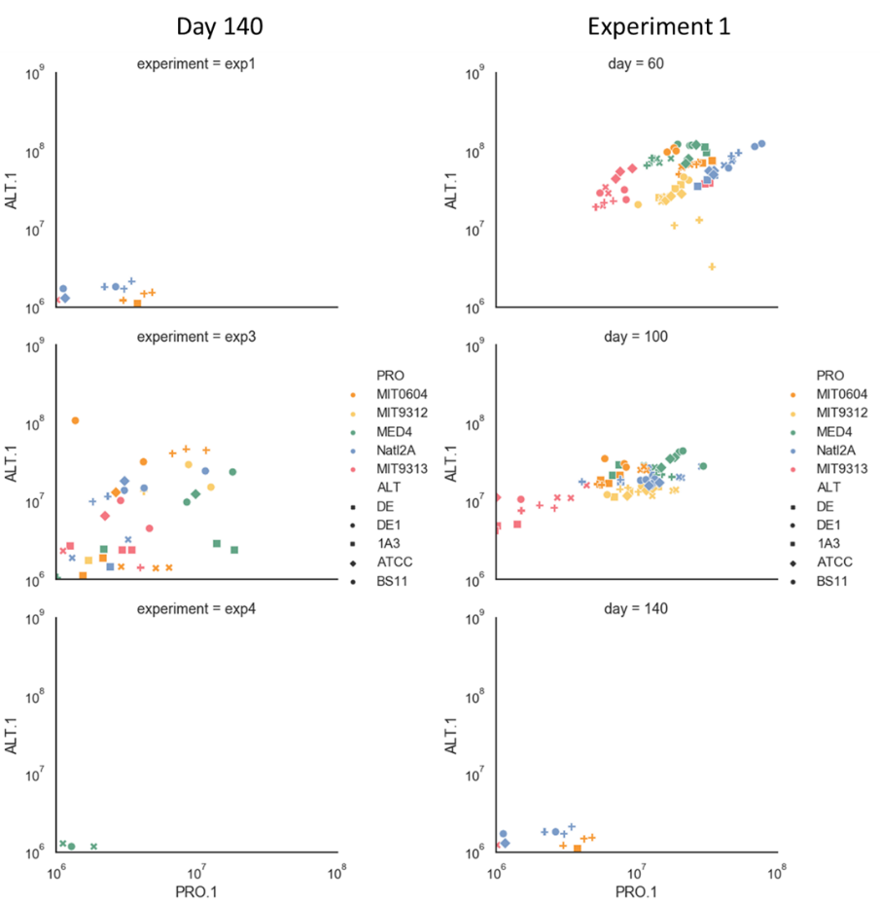

1. Figure 3S
2. add x or NA (instead of empty-white places)
3. add statistics to the bars figures
4. **Predictive test ??**
5. Important day – add the figure for each strain and for all strains
6. Decline model
7. which function is the best for each strain ? slide 11
8. separate between CC to Axenic
9. try to characterize the days after day 100 – Osnat – analyze last 40 days look for characteristics
10. **The Co-culture effect on PRO death rate**
11. Calculate the death rate of PRO with and without Hets (IN Co-culture and Axenic).

Co-culture reduce the mortality rate! – not done, need guidance

1. Figure that Osnat suggested - 30 graphs from exp 1 (all CC+Axenic) of decline and % mortality.